INTRODUCTION

Welcome to University of lerricksville computer science department. This website was created with the purpose of giving out information to current and future students to help them in the academic journey. Whether you're a developer looking to explore the codebase or a user interested in the functionalities, this Readme will guide you through the setup process and provide essential information about the project.

TABLE OF CONTENTS

1. Cloning and setup.
2. Student information.
3. Screenshots of various pages of website.
4. Project insights.

CLONING AND SETUP

Follow these steps to clone and setup on your local machine:

1. Clone the repository:

Git clone <https://github.com/Lerrick12/11035181_DCIT205>

1. Navigate to the project directory:

Cd Lerrick12/11035181\_DCIT205.

1. Install dependencies:

npm install

1. Start the development server:

npm start.

1. Open your browser:

Visit [http://localhost:3000](http://localhost:3000/" \t "_new) to view the project.

STUDENT INFORMATION

Name: Takyi Derrick.

Student ID: 11035181.

SCREENSHOTS

Home or the index page

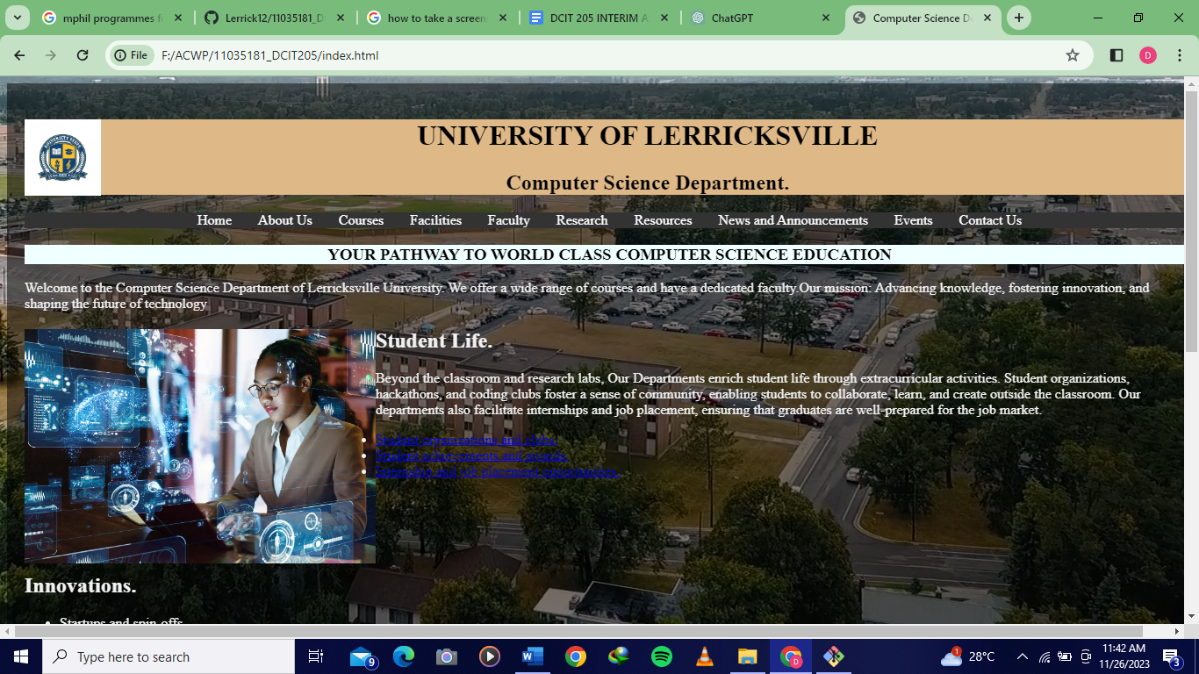

About page

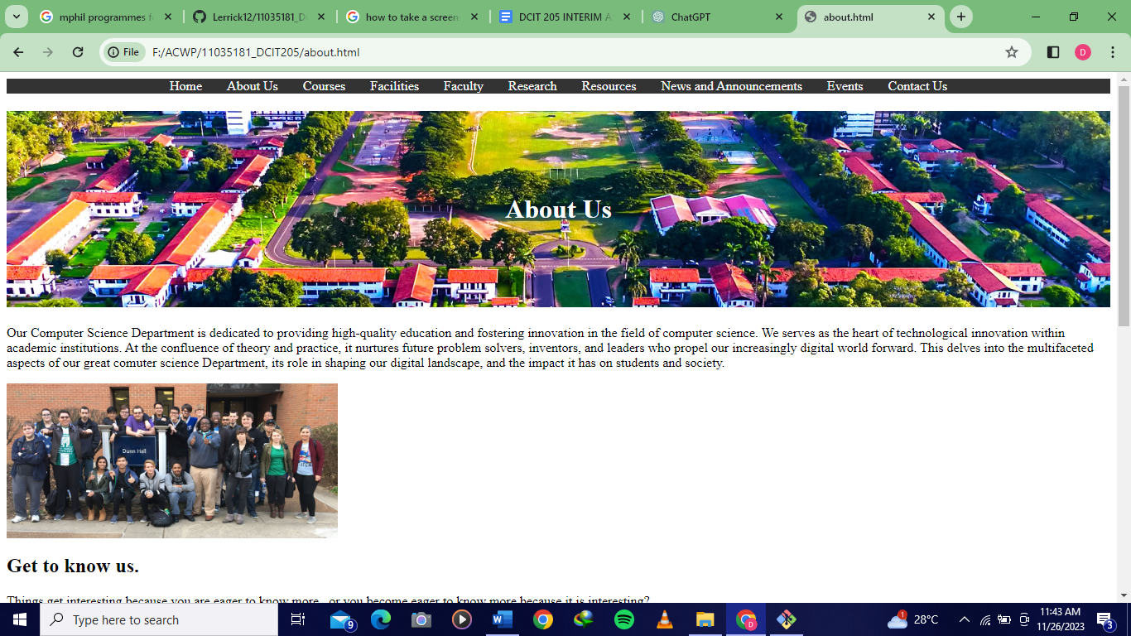

Courses page

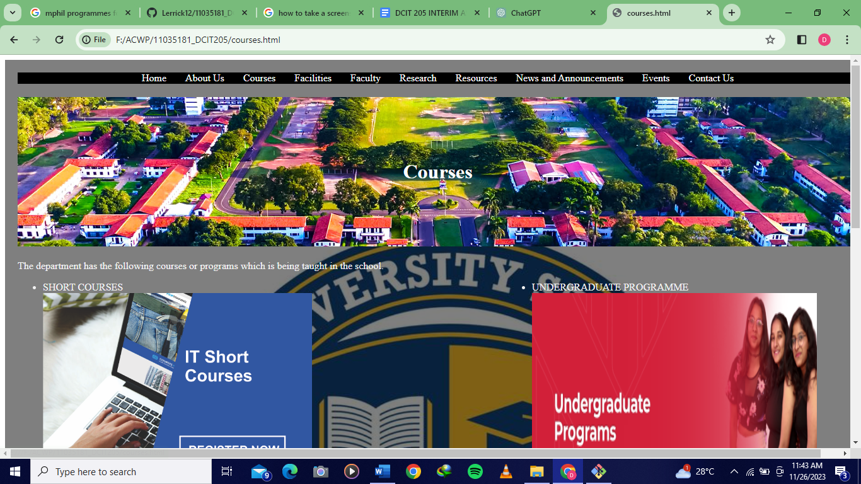

Facilities page

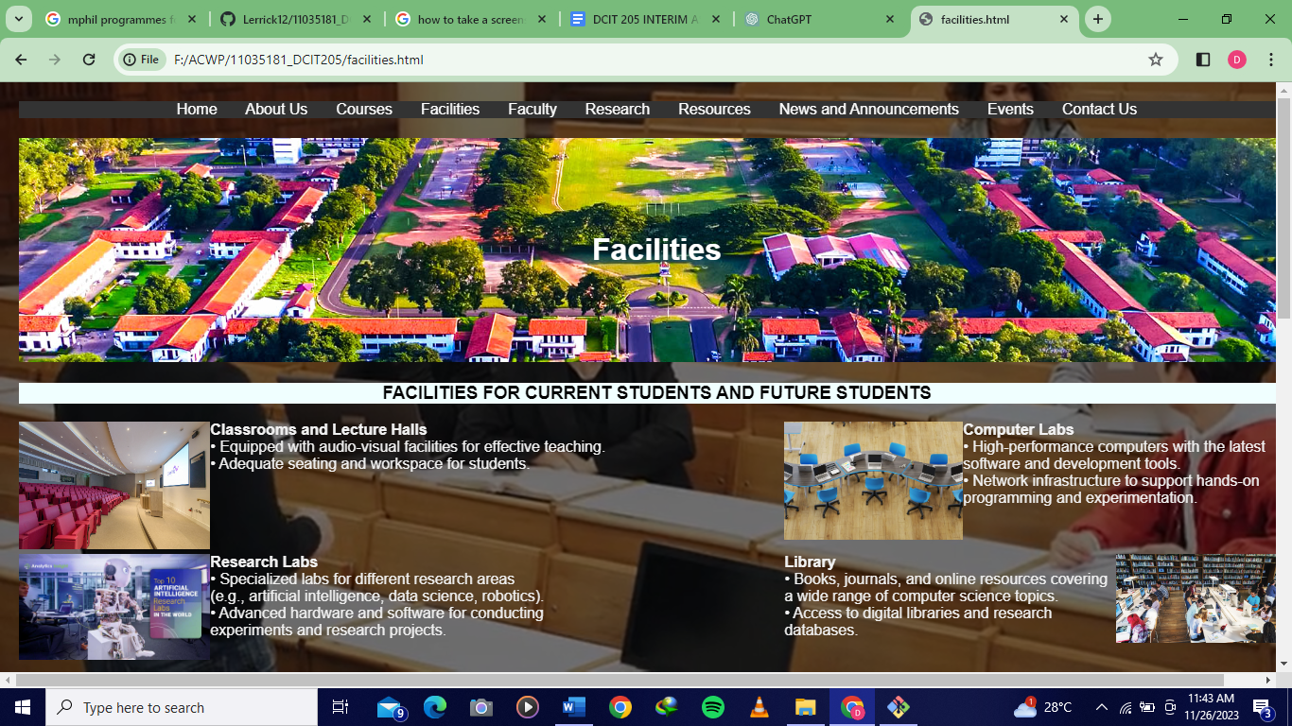

Faculty page

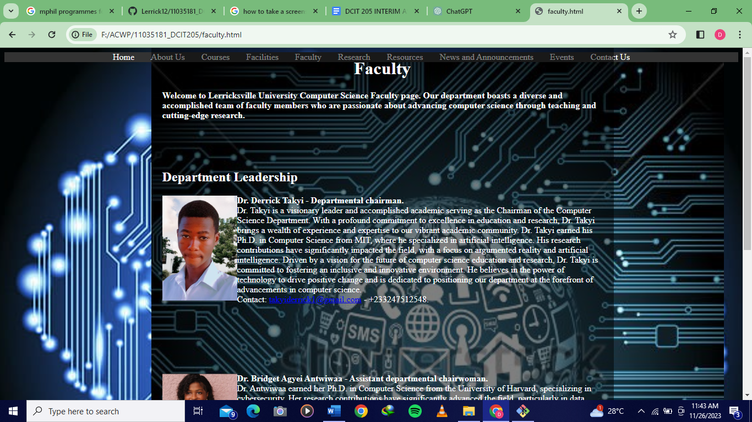

Research page

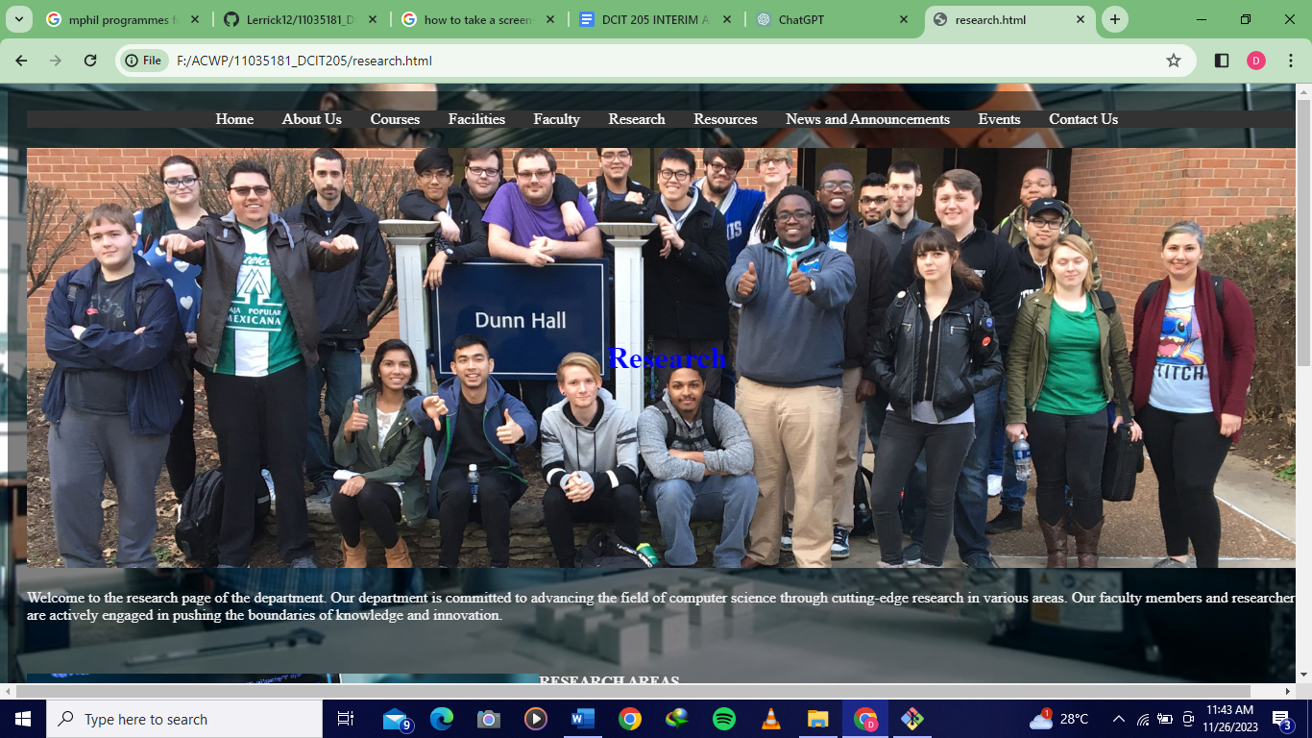

Resource page

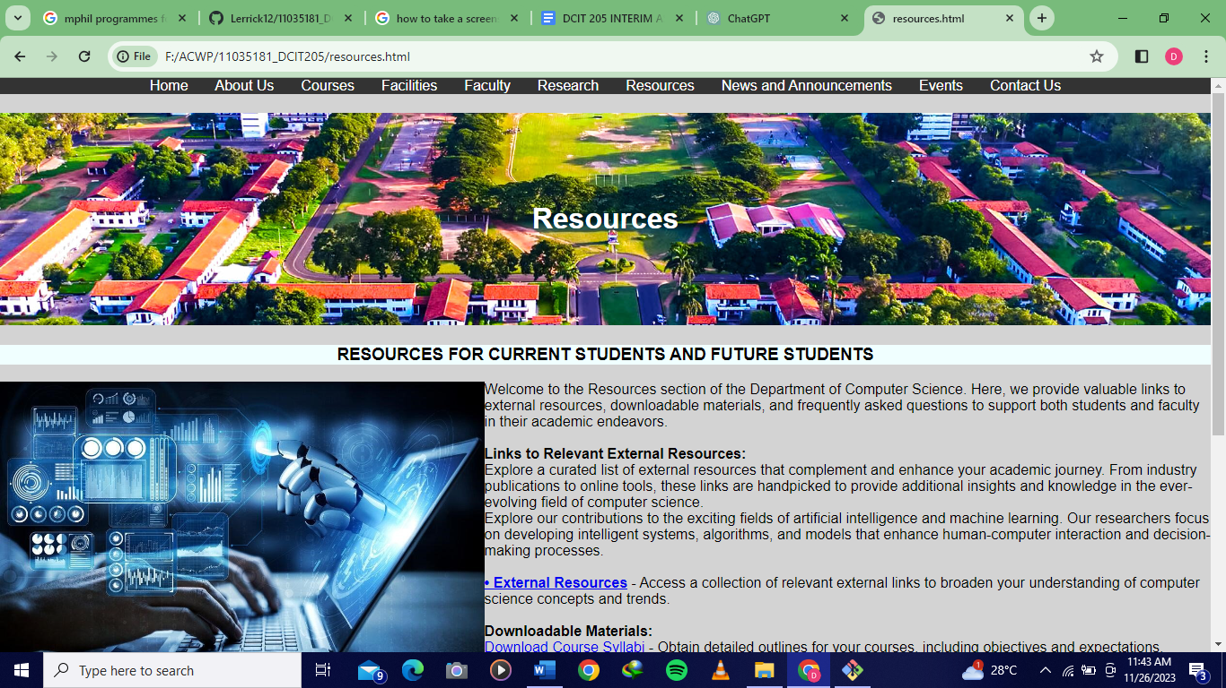

News page

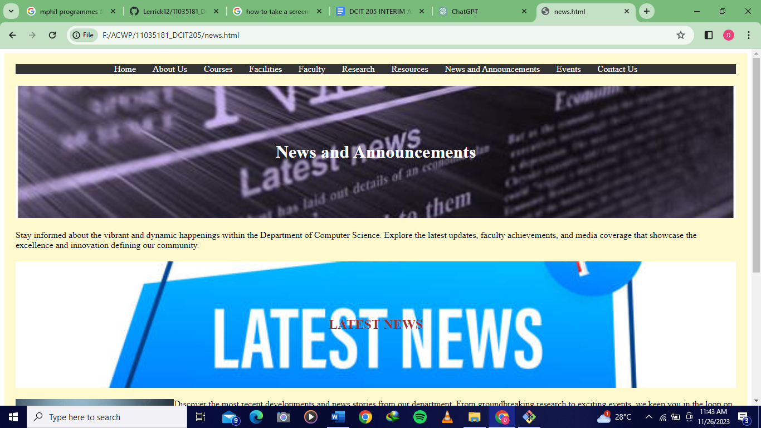

Events page

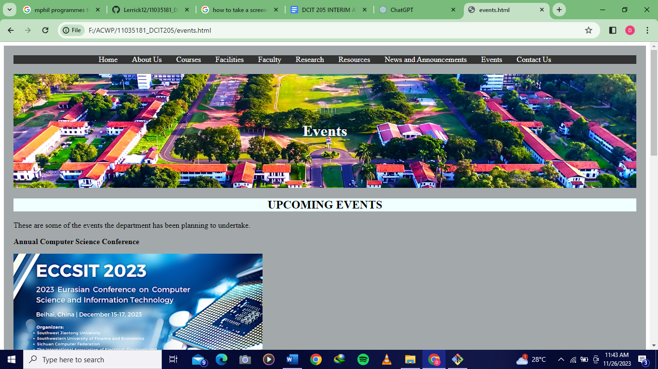

Contact page

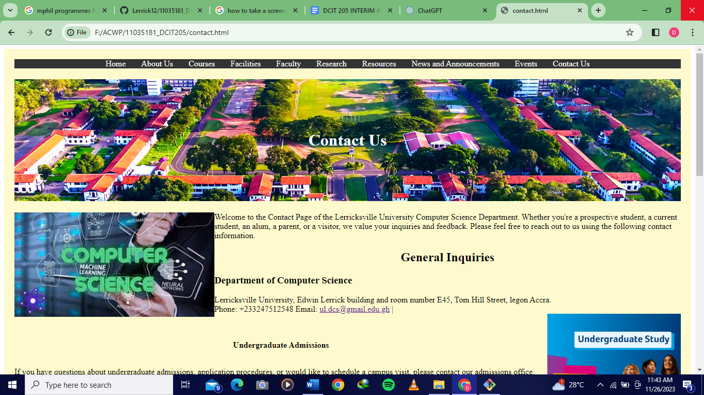

PROJECT INSIGHT

Throughout the development of this project, I have gained valuable insights and learned the following:

1. Technical skills such as html,css, javascript and version control.
2. Problem solving like debugging and optimization.
3. Project management such as planning and organization and task prioritization.